

**Ohm law**

***Team 8***



Members:

* Soriano Montiel Bryan Andrés
* Montaño Ayala Alan Israel
* Vargas Romero Erick Efraín

Teacher: Durán Camarillo Edmundo René

Learning unit: Fundamental analysis circuit

Practice: 02

Sequence: 1CM14

Semester: 2016 – 2017 “A”

Index

1. Voltage dependence 3

2. Dependence of resistance 5

3. Simulations 7

3.1 Dependency of voltage 7

3.2 Dependency of resistance 8

4. Questionnaire 9

5. Conclusions 10

5.1 Soriano Montiel Bryan Andrés 10

5.2 Montaño Ayala Alan Israel 10

5.3 Vargas Romero Erick Efraín 11

6. bibliographies 12

# **1. Voltage dependence**

First of all, in this practice it was made the calculation of the voltage dependence.

Assembling a circuit this circuit expense of a resistor and a potentiometer mainly performed, and for the first part of this practice, once the armed circuit which proceeded to do is change the value of the voltage source, changing from scratch volts to 15 volts, as we saw as we had two resistors, in theory, the current had a variation that because the resistors are passive elements therefore tend to absorb energy also remember the way to calculate the current ( formula 1.1) also in table 1.1 and figure 1.1 is possible to observe the behaviour that had current depending on the voltage was applied.

**Formula 2.1**

$$I= \frac{V}{R}$$

|  |  |  |  |
| --- | --- | --- | --- |
| *Voltage source (V)* | *Current value (measured)* | *Current value (simulated)* | *Current value (calculated)* |
| *0* | *0* | *0* | *0* |
| *1* | *0.436* | *0.444* | *0.2857* |
| *2* | *0.853* | *0.889* | *0.57* |
| *3* | *1.313* | *1.333* | *0.85* |
| *4* | *1.729* | *1.778* | *1.14* |
| *5* | *2.200* | *2.222* | *1.42* |
| *6* | *2.631* | *2.666* | *1.71* |
| *7* | *3.105* | *3.111* | *2.00* |
| *8* | *3.542* | *3.555* | *2.28* |
| *9* | *3.995* | *4.000* | *2.57* |
| *10* | *4.438* | *4.444* | *2.85* |
| *11* | *4.873* | *4.889* | *3.14* |
| *12* | *5.320* | *5.333* | *3.42* |
| *13* | *5.693* | *5.777* | *3.71* |
| *14* | *6.207* | *6.223* | *4.00* |
| *15* | *6.598* | *6.667* | *4.28* |

**Table 1.1**

**Figure 1.1**

# **2. Dependence of resistance**

In the second part of the practice we proceeded in calculating the current value, if it is similar to the above, but now the change is not in the voltage that gives us the power but the resistance applied to the circuit.

The circuit was practically the same as that used for part one of our practice, but this time also measure resistance, making the sum of the value of the potentiometer and the resistance that was already connected to our circuit (1k) as we can see in table 2.1 the current value decreases as more resistance is applied to the circuit, remember that the resistor is a passive element therefore tends to absorb energy, and in figure 2.1 the behavior that had the circuit is also appreciated, take note that the source always gave us 15 volts. In addition, the theorem or formula 2.1 was used to calculate the current.

**Formula 2.1**

$$I= \frac{V}{R}$$

|  |  |  |  |  |
| --- | --- | --- | --- | --- |
| Value potentiometer | Total value of resistance = (Pot. + R) | Current value (measured) | Current value (simulated) | Current value (calculated) |
| 0 Ω | 1 KΩ | 15.18 mA | 0.015 A | 15 mA |
| 250 Ω | 1.25 KΩ | 12.52 mA | 0.013 A | 12 mA |
| 500 Ω | 1.5 KΩ | 10.07 mA | 0.012 A | 10 mA |
| 750 Ω | 1.75 KΩ | 8.54 mA | 0.011 A | 8.57 mA |
| 1000 Ω | 2 KΩ | 7.4 mA | 0.010 A | 7.5 mA |
| 1250 Ω | 2.25 KΩ | 6.76 mA | 9.99 mA | 6.66 mA |
| 1500 Ω | 2.5 KΩ | 5.96 mA | 9.23 mA | 6.00 mA |
| 1750 Ω | 2.75 KΩ | 5.43 mA | 8.001 mA | 5.45 mA |
| 2000 Ω | 3 KΩ | 4.85 mA | 7.500 mA | 5 mA |
| 2250 Ω | 3.25 KΩ | 4.46 mA | 7.061 mA | 4.61 mA |
| 2500 Ω | 3.5K | 4.18 mA | 6.667 mA | 4.28 mA |

**Table 2.1**

**Figure 2.1**

# **3. Simulations**

## **3.1 Dependency of voltage**

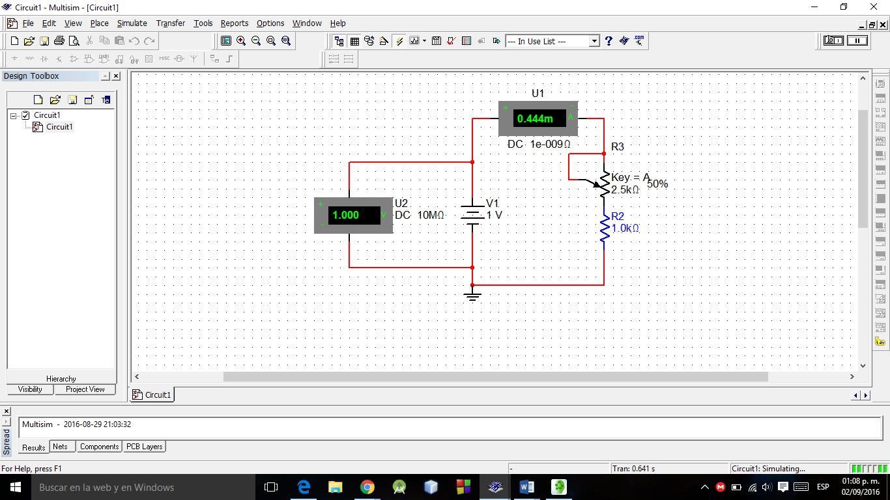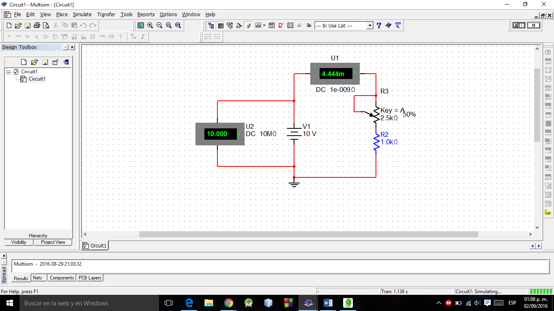

**Figure 3.1.2**

**Figure 3.1.1**

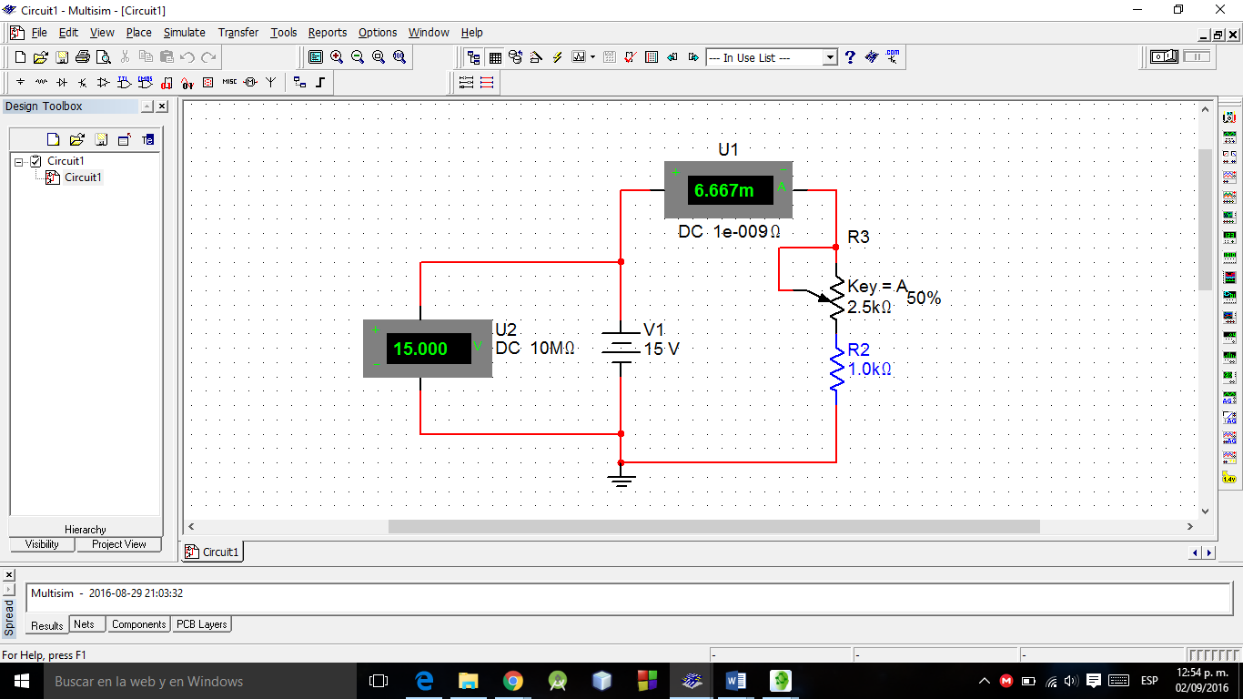

**Figure 3.1.3**

## **3.2 Dependency of resistance**

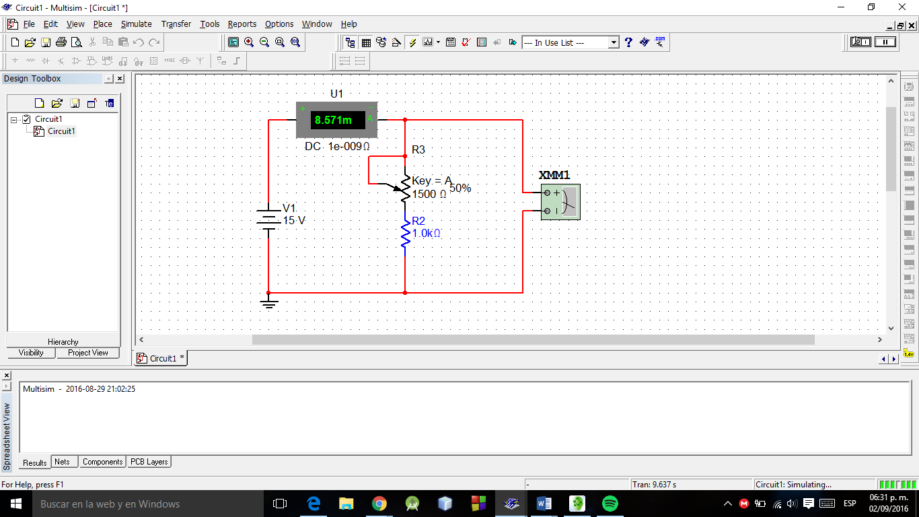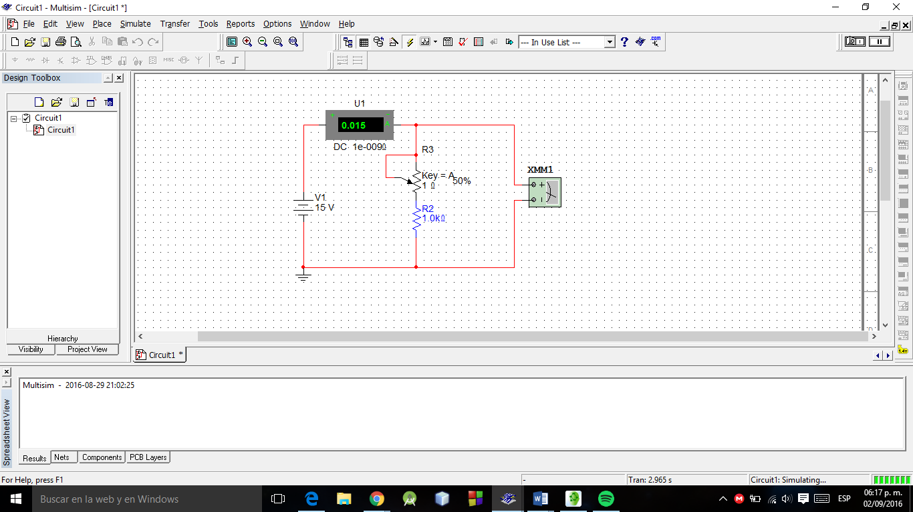

**Figure 3.2.2**

**Figure 3.2.1**

# 

**Figure 3.2.3**

# **4. Questionnaire**

$$I= \frac{V}{R}$$

*1. What is the current value?*

**Formula 4.1**

0.9139 mA see Formula 4.1

$$P= V x R$$

*2. What is the value of the power dissipated by the resistance?*

**Formula 4.2**

0.9130 see Formula 4.2

*3. What happened in resistance effect (if not notice any effect by increasing the voltage of the source)?*

By increasing the voltage source that gives us our strength began to warm

*3.1 Why?*

*You remember that a form of loss of heat energy is then heated by the energy dissipated*

*4. What is the current value?*

257 mA see Formula 4.1

*5. What is the value of the power dissipated by the resistance?*

257 see Formula 4.2

*6. What happened in the resistance effect (if not notice any effect by increasing the voltage of the source)?*

You remember that a form of loss of heat energy is then heated by the energy dissipated

*7. What is the difference with the previous circuit?*

By increasing the voltage in the second circuit there was a significantly greater heating even with less voltage.

*7.1 Why?*

Second circuit resistance is much smaller than the former

# **5. Conclusions**

We have realized the true importance of Ohm's law and thanks to this practice now know the dependence of voltage as the dependence has resistance also confirmed that indeed the warm is a waste of energy, make the "experiment" with the resistors in the section of the questionnaire we could check.

## **5.1 Soriano Montiel Bryan Andrés**

*In this practice we know some of the effects caused by the current, one of these effects applied to the resistance, which upon receiving a high load these devices become very warm, so goes this way these dissipate that energy.*

*But this effect changed depending on circuit we do, because one of them despite having a smaller amount of current, its component raised his temperature more quickly.*

*Also, we observe the current variation, by applying different current capacities.*

## **5.2 Montaño Ayala Alan Israel**

*With the results obtained in the practice we can concluded that the voltage, current and resistance in the circuit elements have a relationship. This was observed when the value of the source voltage change and the current increased, also by varying the resistance change is observed in the current but this time decreases, since by varying the voltage the resistance was constant and varying the resistance the voltage was constant it can be assumed that the current depends on the voltage and resistance. Ohm's law gives the relationship of voltage, current and resistance as I = V / R, which can be seen in the results.*

*In the last part of the practice could be seen that increasing the voltage in the circuit equals warming the resistance, that is because power equals current per voltage, since power is the rate at which energy is consumed and energy in the resistance is dissipated as heat, the resistance is heated.*

## **5.3 Vargas Romero Erick Efraín**

*With the results of this practice, the current is something that we measure frequently and we realize how much variation both by raising the voltage and resistance, which are the two variables that has its formula, also in the section of the questionnaire do the little "experiment" with the two resistors of 1k both like 1Ω see that happening if the voltage what we raised, and what happened was a waste of energy.*

*In addition, the use of the measuring instruments further reinforce the use of ammeter, multimeter, etc.*

# **6. bibliographies**

**6.1** Charles Alexander. (2006). Fundamentos de Circuitos. Mexico: McGraw-Hill Interamerica.

**6.2** Thomas L. Floyd. (2007). Principios de Circuitos Eléctricos. México: Pearson.